Rootedness and Openness in
The Life and Works of Véronique Tadjo (b. 1955)

submitted by Tim Steckler

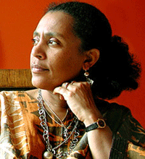

“The truth is revealed in people’s eyes. Words have so little value. You need to get under people’s skins. See what is inside.”
-The Shadow of Imana: Travels in the Heart of Rwanda

Speaking at a book reading of her novel Far from my Father at the Library of Congress in Washington DC, Véronique Tadjo was asked a question about her values as an author. She commented with a simple phrase, “Rootedness and openness.” She went on to explain that this means being rooted in a home culture, yet still open to the world. Tadjo, as an afrocentric writer, balances her origins with the wider world in a way that electrifyingly draws her reader in.
Véronique Tadjo, writer and poet, provides many distinct pairs of spectacles for her reader, and with each new pair draws her reader into a world marked by humanity and hope. This ability is the reason her works have wide appeal and have been widely acclaimed. Her vast collection of awards include most notably the prestigious African francophone literary award, Le Grand Prix Litettérete d’Afrique Noire, which she won in 2005. Part of what bolsters Tadjo to be such an effective and empathetic writer is her enormous breadth of talents and experience. Tadjo is an African who also draws on her distinctive French and francophone background and heritage. In addition, she also writes extensively in English. In both languages, Tadjo demonstrates the unusual ability to communicate messages to a wide range of readers through novels, poetry, and illustrated children’s books. Her stories encompass the lives of individuals throughout Africa, myths with deep origins throughout the continent, the effects of war and economic hardship, as well as everyday challenges faced by Africa and Africans. These stories are bolstered by a vantage point she developed through living in numerous countries throughout Africa and beyond. Tadjo’s African and global experiences, relating to so many different people, and her vast array of skills as a storyteller put her in an advantageous position to sketch “the truth revealed in people’s eyes” and to give the reader a vast array of vantage points from which to answer the question, “What does it mean to African?”
This biography describes Tadjo’s life through the context she writes in, her life within this context, and the themes which have marked her lifework. The context includes her upbringing in Côte D’Ivoire and the conflict that ravaged the nation. The themes include her ability to write in both French and English as well as her afrocentric themes especially her inclusion of African mythology and her focus on particular problems facing Africa, such as her writings on Rwanda

Conflict and Aftermath
Tadjo was born in 1955 in France to an Ivorian father and French mother. She grew up mostly in Abidjan, Côte D’Ivoire, and earned her Bachelor of Arts degree in English at the University of Abidjan. Tadjo has noted that her choice to study English was “the best decision” she could have made. She proceeded to earn her doctorate at The Sorbonne in France in African American Literature and Civilization, and her knowledge of English paved the way for her to her to earn a Fulbright research scholarship at Howard University in 1983. Once back in Côte D’Ivoire, Tadjo gained an entirely new perspective when teaching English in a relatively poor region consisting largely of Muslims, in the north of the country. Some of her first writings, such as Latérite, were poems based on her experiences in the north, where she fell in love with the place and the people. She wrote extensively on the connection to land that characterizes people from the north of Côte D’Ivoire and other parts of West Africa.
This celebration of Côte D’Ivoire’s northern Muslim population and their connection to the land was particularly insightful especially in view of what was to follow politically. This context is crucial to understanding how Tadjo incorporated this region into her writings. Located in West Africa and roughly the size of the US state of New Mexico, Côte D’Ivoire is a nation with vast resources and a long history of being a thriving African society, yet its geopolitical structure has played into the turmoil that ravaged the nation starting in the early 1990’s.
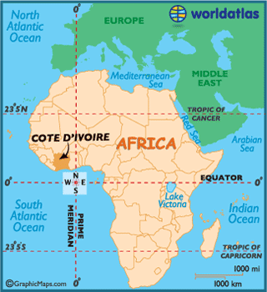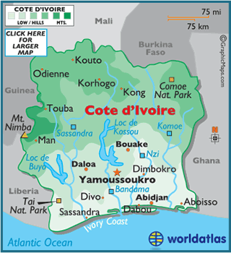
The country achieved independence from France in 1960 and for decades remained an economic powerhouse in West Africa selling coffee, cotton, and cocoa. In 1993, the country’s fortunes began to change with the death of the first president Felix Houphouët-Boigney, and a decreased international demand for cocoa. As in many former colonies whose economies were shaped by Europeans to rely on one or few commodities, the “monocrop” of cocoa is a large part of Côte D’Ivoire’s GDP, and the reduced global demand caused a severe economic downsturn. Many immigrants, particularly from other West African countries had come to work on the cocoa fields, and when the economic crisis hit, Ivoirians’ tensions with these foreigners spurred a growing conflict.
The new leader Henry Konan Bédié, appealed to ethnicity and sought to win voters by blaming the economic downturn on foreigners (particularly migrant workers from other West African countries) and Muslims from the arid northern regions of the country. This process of “Ivorization” by targeting these other ethnic groups was a part of populist, nationalist sentiment that sharply divided the nation. Those deemed foreigners suffered severe reductions on their rights.. A 1999 coup led to the election of President Laurent Gbagbo, who shattered much of the remaining stability. Violence was carried out against foreigners and Muslims residing in the Abidjan and surrounding towns. The 2000’s were marked by a stagnant economy and Gbagbo’s repeated atrocities against “foreigners”, including one massacre in Abidjan where 150 people were killed. After extensive UN and African Union pressure, the opposition leader, Alassane Ouattara, was allowed to run against Gbagbo, but when Ouattara won, Gbagbo refused to stand down. In 2010, dozens of citizens died in riots and tensions in the area increased with extensive fighting between competing armies. By 2011 hundreds of thousands of Ivoirians were displaced, particularly from the north. Since Ouattara gained control of the country in 2011, the nation has been in recovery, its economy growing by 8% each year, yet the memory of the war has not been forgotten.
Tadjo’s writings about Côte D’Ivoire before the war may have been celebratory while afterwards they have been reflective on the post-conflict Ivoirian experience. She talks about how individuals who returned home may have found their homes resettled by another group of individuals. She writes about families that have been torn apart, and countless individual lives that have been severely altered or changed. Tadjo describes how Ivorians, including herself, must return home and reconcile with the changed reality.
In Far from my Father, the aftereffects of the Ivorian Civil War is a major theme. Written in 2014, it describes a woman named Nina travelling back to her native Côte D’Ivoire after years of exile due to the war. She arrives in Abidjan, an area still recovering from the onslaught that had caused so many thousands to leave. Nina’s family greets her warmly, though a man attempts to steal her bags during the interaction and her young cousin cannot stop crying. This bittersweet moment is a homecoming where Nina’s father has died. The book depicts snippets of Nina’s travel back home, her interactions with her family in the wake of her father’s death, the differences in her war-wrecked homeland. She notices, “No one knows where things are headed. People are speaking in harsh tones, growing more radical, more set in their opinions. Everyone is talking at once and no one is listening. We look at each other with stony faces, full of distrust.” Nina tries to find her new place in this dark world, sorting through her father’s papers, arranging the funeral, meeting an old lover. Interactions with the world around her are strained. Tadjo uses a powerful animal motif to describe the feeling of being back in Côte D’Ivoire.

“Ants were an entirely different story… she had learned that they avoided senseless violence. But the nature of their sophisticated social system appeared to lead the most intelligent among them almost irresistibly to wage war against their less aggressive races, even though they were necessary for their own survival. It is in this that they come closest to the most advanced human societies.”

Nina’s struggle, the brutal world like the one of the ants she entered into that had been wrought through the powerful inflicting havoc on the innocent, relates to Tadjo’s experience. Commenting on what it is like to travel and come home, Tadjo says she never thought of herself as “in exile” during her years abroad in South Africa and elsewhere, but “When the feeling of war came, you have the feeling of exile. You know you are an exile when you know the place you left has changed.” Through the voice of Nina, Tadjo takes the reader to her own personal experience, and the stories of so many who return home to a country fresh from the onslaught of war. The themes of familiarity yet difference, happiness mixed with grief, the ties of the old pulling one from their place in the present, are all invoked in her story. Notwithstanding, there is a feeling of forward movement: that these events happened, yet as is common in the human experience, forward movement is inevitable in the struggle to survive. Tadjo depicts this most human and thus universal of experiences, while noting the distinctiveness of her country and culture. Nina’s thoughts and fears are in a sense Tadjo’s tools to bring the reader to her homeland.

Language and Humanization
Another conflict exists in Africa that positions a writer like Tadjo to have a positive effect: the divide between Anglophone and Francophone Africa. Two thirds of Africa was colonized by British and French speaking powers (France and Belgium). Even after traditional colonialism ended, English and French-speaking countries have remained critically divided. Linguistic (and cultural) divisions have created artificial divisions among African peoples, so much so that the African Union election in which South Africa’s Dlamini-Zuma defeated incumbent Gabonese Jean Ping was widely touted as a victory of Anglophone Africa. Divisions over language affiliation can become so divisive that violence can ensue. In Cameroon, for example, a country with a francophone and an Anglophone community, the French-speaking majority has been known to limit the rights of English speaking Cameroonians and even incite violence, stoking a conflict over identity.
The divide between French and English speakers creates a disruption in the sharing of ideas throughout Africa. In West Africa, where francophone Côte D’Ivoire shares its eastern border with Ghana, peoples from the same ethnic background can have significant difficulty in communicating – a divide that originates with the colonial division of the continent into British and French controlled areas. These arbitrarily imposed imperial languages block connections between Africans in scholarly and literary fields: French-speaking scholars and writers, for example, are often cut off from English scholarship in Africa. While there are efforts to bridge this scholarly divide, the separation is a significant issue in the setting Tadjo writes in.
Her global experience and multilingual abilities have helped her to bridge the linguistic (and cultural) gap. Tadjo has written, taught, and lived in Nigeria, Mexico, Rwanda, France, and the United States. She taught for fourteen years in South Africa at the University of the Witwatersrand as head of the French department. In 2015 she moved from South Africa, and she currently divides her time mainly between Abidjan in Côte D’Ivoire and London. She also bridges the academic and the everyday world, her human contact with ordinary Africans leaving an indelible imprint in her writings. She considers English her “scholarly profession” and French her “creative profession.” Through her writings she has helped English speakers understand the French speaking worlds of Côte D’Ivoire and Rwanda.
Tadjo arrived with twelve other African writers shortly after the end of the brutal genocide that wiped out hundreds of thousands of Rwandans. The Shadow of Imana, Travels in the Heart of Rwanda depicts Tadjo’s personal reflection on her travels in Rwanda where she recounts seeing the beautiful, lively streets of Kigali, as if the brutal genocide had never happened. Yet she soon finds that the trauma, the absolute atrocities of the war, still exist in the minds of the people with whom she interacts. And through her literary and translation abilities, she is able to convey to the reader what these individuals see.
The powerful motif of eyes is most explicit in this book. Tadjo first meets a refugee from Rwanda in South Africa before she embarks on her journey. She sees something in his eyes, the world of experience which she cannot ever quite know, one in which he was forced to travel on foot the thousands of miles from Rwanda through Zaire (modern day Democratic Republic of the Congo) and several other countries to reach South Africa. Tadjo also reveals the dramatic difference in worlds between a Rwandan genocide survivor and Rwandan tourists in a vignette where this man who lived near a church, which was the site of a mass massacre by Hutu militants was now giving tours to the residents of the town. Tadjo offered her account of how she saw this tour guide.

“I wonder what will happen to him. Why is he there, amid these human remains, these bones? He explains, replies to questions without betraying any emotion. He touches the relics, pushes open doors, guides the visitors to the places where the remains lie in piles. He displays them as he would display anything else, as if he were in a museum. He talks, knowing that our imagination will never be able to get anywhere close to the reality. Deep down, he does not understand why we are coming to stir up Evil. Perhaps in the end all this will turn against him as he guards the evidence of our inhumanity. He cannot understand what we have come here to seek, what is concealed in our hearts. What hidden motive drives us to gaze wide-eyed at death distorted by hatred?”

By asking the questions from the point of view of this tour guide, Tadjo enables the reader to even just slightly glimpse the experience of this genocide survivor, this Rwandan man, this African. She tells a story artfully, in an Afrocentric manner and presents a new point of view of the human experience of the aftermath of war.

Afrocentricity through mythology
The way that Tadjo conveys how these Rwandans saw their world from their own perspectives begs a larger question: When we are talking about “African issues”, from what perspective are we considering these matters? Asante has coined a term “Afrocentricity” to challenge the lens that is used to view and depict Africa and Africans. Mazama explains, “Afrocentricity contends that our main problem as African people is our usually unconscious adoption of the western worldview and perspective and their attendant conceptual frameworks.” Adapting a different mindset that recognizes the importance and significance of understanding African cultures history from the point of view of the African and not the colonizer or outsider permits afrocentric views so critical to grasping the nature of the continent.
One of the ways Tadjo’s writings reflect afrocentricity is through her crucial and extensive use of African mythology in her storytelling. Tadjo writes,

“I follow the African tradition of storytelling which gives me a great freedom of interpretation of our myths and legends. I am interested in preserving the richness of our cultural heritage for the generations to come. Many of us live in big African urban centres or in the Diaspora and are increasingly losing contact with oral traditions. One after the other our stories and mythical characters are disappearing. Instead of lamenting this phenomenon, I feel it is my role as a writer and as an artist to fight against alienation and amnesia.”

Lord of the Dance: An African Retelling focuses on the mythologies of the Senufu people of Côte D’Ivoire. Similarly, Mami Wata and the Monster , a story and picture book for children references a central figure in West and Central African mythology, Mami Wata. Her novel Reine Pokou incorporates the adult tale and theme of an old African myth, referencing a “blind kingdom” that integrates ideas concerning the blindness, wealth, and corruption of rulers throughout Africa.
Tadjo’s award-wining children’s book, Mami Wata and the Monster, using the lens of mythology reveals Africa through another set of eyes, or rather, through one eye. This story, which won the UNICEF award in 1993, is about a water goddess, Mami Wata, who is a friend of both the fish and the fishermen who come to her waters. Yet soon the fishermen complain that a terrible monster eats men, women, and especially children who approach the water. It is described as “carnivorous,” having a hideous face, an eye in the middle of his forehead, and several rows of very sharp teeth.” Yet when Mami Wata comes to investigate this fiend, she notices that “he moaned a lot…his body shook all over. He burst into tears… and fell into a deep sleep.” Having pity on the monster, the goddess comforts him. It is revealed that a witch cursed the monster when he had refused to marry one of the witch’s daughters. Mami Wata proceeds to teach him how to dance and sing, and “while he was still laughing, Mami Wata saw he had changed completely. He had become the young man he was before.” The men, women, and children he had eaten reappear and travel home, and everyone celebrates in the villages. “Everybody rejoiced, the huts were decorated and beautiful boats danced down the river.”
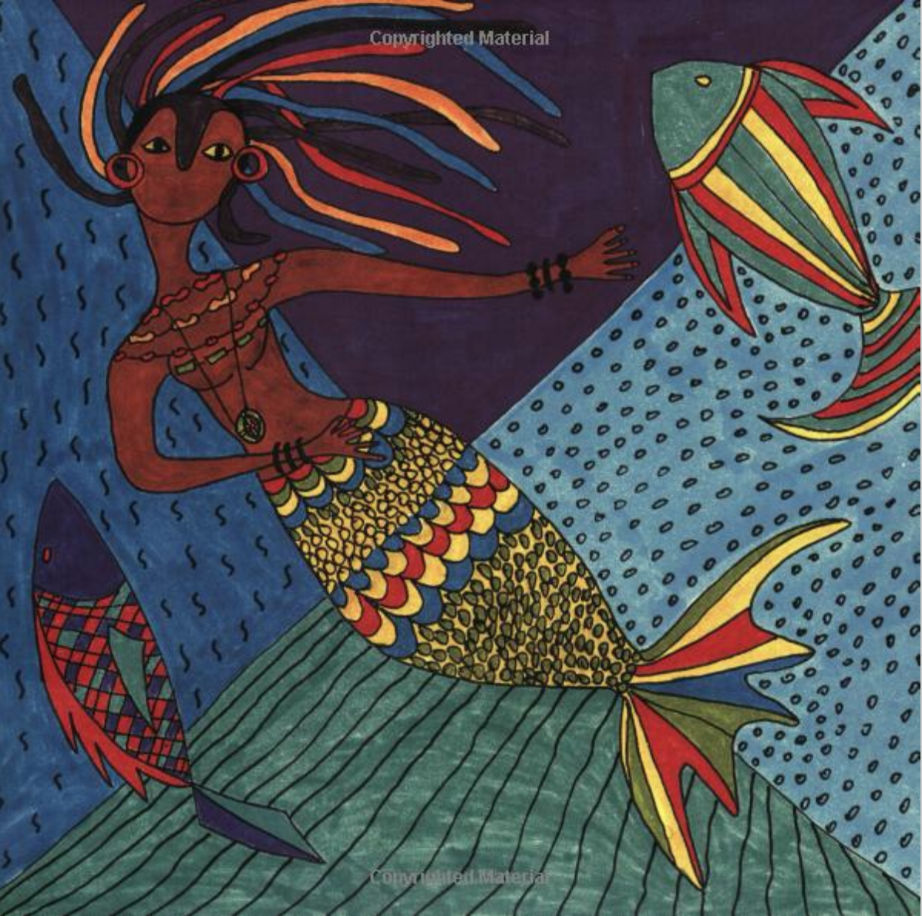
Tadjo’s account of Mami Wata is a beautiful recounting of an ancient West and Central African folktale. Through invoking these tales, Tadjo is able to not only bring alive an old story to a young audience, but tells it in a way that celebrates the modern African experience so that that all readers, young and old, black African, Asian, American or European can understand. Tadjo likely learned more extensively about her through her experiences teaching in Nigeria, where the tradition of this mermaid-liked goddess is particularly alive. Mami Wata appears in numerous stories, often as a seductive or luring figure to local fishermen. Yet Tadjo transforms this figure into a more empowering image. In effect, she is using Mami Wata as an empowered female figure who creates change, in an afrocentric way. Tadjo provides bright, beautiful illustrations of various scenes in the story giving the reader a visual to enhance the African setting of the myth. The positive story and happy, colorful illustrations bolster a strong message of hope. An empowered female African figure pierces through and resolves a conflict for the betterment of everyone in the community. Hope is the resounding message from this book.

Conclusion
The resounding message of hope is not specific to Mami Wata, where Tadjo teaches her readers young and old of an old African legend and elevates the powerful African female hero. Hope is also found in The Shadow of Imana, where Tadjo not only writes about the hardship of Rwandans, but gives the reader an image individuals emerging from genocide and doing what they need to in order to move forward to normalcy and peace. So too Far From My Father, conveys a feeling of acceptance and forward movement despite the catastrophe that has befallen her native Côte D’Ivoire. Not only is she a masterful storyteller, but she is able to pull her readers in to look at Africa through the “eyes” of an African. Tadjo’s afrocentric perspective elevates that perspective to counter stereotypes, cultural norms, and the fears that are so beset in conversations involving the continent, leaving her readers with a resounding sense of the humanity and hope that characterize Africans. Tadjo elevates the conversation about Africa and our humanity to new heights.

Bibliography

"Africa: Anglophone vs Francophone in the African Union." AllAfrica. December 01, 2015. Accessed November 19, 2017. http://allafrica.com/stories/201511302599.html.

Asante, Molefi K. Afrocentricity, the theory of social change. Chicago, IL: African American Images, 2003

"Cote D'Ivoire." World Atlas - Maps, Geography, travel. April 07, 2017. Accessed November 19, 2017. http://www.worldatlas.com/webimage/countrys/africa/ci.htm.

Dickovick, J. Tyler. Africa. Landam, MD: Stryker-Post publications, 2014.

Fokwang, Jude. Canadian Journal of African Studies / Revue Canadienne Des Études Africaines 38, no. 2 (2004): 467-69. doi:10.2307/4107321.

Garane, Jeanne. "Véronique Tadjo." Contemporary African Writers, Tanure (ed. and introd.) Ojaide, Gale, 2011, pp. 260-267. Dictionary of Literary Biography (DLB): 360. EBSCOhost,

Gray, Stephen. 2003. "Véronique Tadjo Speaks with Stephen Gray." Research In African Literatures 34, no. 3: 142. Academic Search Complete, EBSCOhost (accessed November 20, 2017).

Läderach, P., A. Martinez-Valle, G. Schroth, and N. Castro. 2013. "Predicting the future climatic suitability for cocoa farming of the world's leading producer countries, Ghana and Côte d'Ivoire." Climatic Change 119, no. 3/4: 841-854. Academic Search Complete, EBSCOhost (accessed December 13, 2017).

Library of Congress. “Véronique Tadjo.” YouTube, YouTube, 19 Dec. 2014, www.youtube.com/watch?v=3SqmTqtpxNs.

Mayes, Janis, and P. Searle. "Veronique Tadjo." African Writing Online. http://www.african-writing.com/four/veroniquetadjointerview.htm.

Mazama, Ama. "The Afrocentric Paradigm: Contours and Definitions." Journal of Black Studies 31, no. 4 (2001): 387-405. http://www.jstor.org/stable/2668022.

Mitchell, Matthew I. "Insights from the Cocoa Regions in Côte D'Ivoire and Ghana: Rethinking the Migration-Conflict Nexus." African Studies Review 54, no. 2 (2011): 123-44. http://www.jstor.org/stable/41304778.

Mudimbe-Boyi, Elisabeth. "Breaking Silence and Borders: Women Writers From Francophone and Anglophone Africa and the Caribbean." Callaloo 16, no. 1 (1993): 75-76. doi:10.2307/2931817.

Tadjo, Véronique. The shadow of Imana: travels in the heart of Rwanda. Waveland Press, 2015.

Tadjo, Véronique, and Amy Baram Reid. Far from my father. University of Virginia Press, 2014. 11

Tadjo, Véronique, and Gisela Greatorex. Mama Wata und das monster = Mamy Wata and the monster. London: Milet, 2000.

Tadjo, Véronique. “Biography.” Véronique Tadjo, 2013, veroniquetadjo.com/?page_id=21.

van Stipriaan, Alex (2005). "Watramama/Mami Wata: Three centuries of creolization of a water spirit in West Africa, Suriname and Europe". Matatu: Journal for African Culture and Society, 27/28, 323-3

Mayes, Janis, and P. Searle. "Veronique Tadjo." African Writing Online. http://www.african-writing.com/four/veroniquetadjointerview.htm.
Véronique Tadjo. The shadow of Imana: travels in the heart of Rwanda. Waveland Press, 2015. 11
LibraryOfCongress. “Véronique Tadjo.” YouTube, YouTube, 19 Dec. 2014, www.youtube.com/watch?v=3SqmTqtpxNs.
Tadjo, Véronique. “Biography.” Véronique Tadjo, 2013, veroniquetadjo.com/?page_id=21.
LibraryOfCongress. “Véronique Tadjo.” YouTube, YouTube, 19 Dec. 2014, www.youtube.com/watch?v=3SqmTqtpxNs.
Tadjo, Véronique. “Biography.” Véronique Tadjo, 2013, veroniquetadjo.com/?page_id=21.
Dickovick, J. Tyler. Africa. Landam, MD: Stryker-Post publications, 2014.
Map of Africa and Côte d’Ivoire. "Cote D'Ivoire." World Atlas - Maps, Geography, travel. April 07, 2017. Accessed November 19, 2017. http://www.worldatlas.com/webimage/countrys/africa/ci.htm.
Läderach, P., A. Martinez-Valle, G. Schroth, and N. Castro. 2013. "Predicting the future climatic suitability for cocoa farming of the world's leading producer countries, Ghana and Côte d'Ivoire." Climatic Change 119, no. 3/4: 841-854. Academic Search Complete, EBSCOhost (accessed December 13, 2017).
Mitchell, Matthew I. "Insights from the Cocoa Regions in Côte D'Ivoire and Ghana: Rethinking the Migration-Conflict Nexus." African Studies Review 54, no. 2 (2011): 123-44. http://www.jstor.org/stable/41304778.
Dickovick, J. Tyler. Africa. Landam, MD: Stryker-Post publications, 2014.
Id.
LibraryOfCongress. “Véronique Tadjo.” YouTube, YouTube, 19 Dec. 2014, www.youtube.com/watch?v=3SqmTqtpxNs.
Tadjo, Véronique, and Amy Baram Reid. Far from my father. University of Virginia Press, 2014. 11
Tadjo, Véronique, and Amy Baram Reid. Far from my father. University of Virginia Press, 2014. 45
LibraryOfCongress. “Véronique Tadjo.” YouTube, YouTube, 19 Dec. 2014, www.youtube.com/watch?v=3SqmTqtpxNs.
"Africa: Anglophone vs Francophone in the African Union." AllAfrica. December 01, 2015. Accessed November 19, 2017. http://allafrica.com/stories/201511302599.html.
Fokwang, Jude. Canadian Journal of African Studies / Revue Canadienne Des Études Africaines 38, no. 2 (2004): 467-69. doi:10.2307/4107321.
Mudimbe-Boyi, Elisabeth. "Breaking Silence and Borders: Women Writers From Francophone and Anglophone Africa and the Caribbean." Callaloo 16, no. 1 (1993): 75-76. doi:10.2307/2931817.
Gray, Stephen. 2003. "Véronique Tadjo Speaks with Stephen Gray." Research In African Literatures 34, no. 3: 142. Academic Search Complete, EBSCOhost (accessed November 20, 2017).
Garane, Jeanne. "Véronique Tadjo." Contemporary African Writers, Tanure (ed. and introd.) Ojaide, Gale, 2011, pp. 260-267. Dictionary of Literary Biography (DLB): 360. EBSCOhost, ezproxy.prin.edu:2048/login?url=http://search.ebscohost.com/login.aspx?direct=true&db=mzh&AN=2011650743&site=ehost-live.
Id
Tadjo, Véronique. The Shadow of Imana: Travels in the Heart of Rwanda. Waveland Press, 2015. 11.
Asante, Molefi K. Afrocentricity, the theory of social change. Chicago, IL: African American Images, 2003
Mazama, Ama. "The Afrocentric Paradigm: Contours and Definitions." Journal of Black Studies 31, no. 4 (2001): 387-405. http://www.jstor.org/stable/2668022.
Tadjo, Véronique. “Biography.” Véronique Tadjo, 2013, veroniquetadjo.com/?page_id=21.
Garane, Jeanne. "Véronique Tadjo." Contemporary African Writers, Tanure (ed. and introd.) Ojaide, Gale, 2011, pp. 260-267. Dictionary of Literary Biography (DLB): 360. EBSCOhost, ezproxy.prin.edu:2048/login?url=http://search.ebscohost.com/login.aspx?direct=true&db=mzh&AN=2011650743&site=ehost-live.
Mayes, Janis, and P. Searle. "Veronique Tadjo." African Writing Online. http://www.african-writing.com/four/veroniquetadjointerview.htm.
Tadjo, Véronique. “Biography.” Véronique Tadjo, 2013, veroniquetadjo.com/?page_id=21.
Tadjo, Véronique, and Gisela Greatorex. Mama Wata und das monster = Mamy Wata and the monster. London: Milet, 2000.
Tadjo, Véronique, and Gisela Greatorex. Mama Wata und das monster = Mamy Wata and the monster. London: Milet, 2000.
Id
Id
Id
van Stipriaan, Alex (2005). "Watramama/Mami Wata: Three centuries of creolization of a water spirit in West Africa, Suriname and Europe". Matatu: Journal for African Culture and Society, 27/28, 323-3
Garane, Jeanne. "Véronique Tadjo." Contemporary African Writers, Tanure (ed. and introd.) Ojaide, Gale, 2011, pp. 260-267. Dictionary of Literary Biography (DLB): 360. EBSCOhost, ezproxy.prin.edu:2048/login?url=http://search.ebscohost.com/login.aspx?direct=true&db=mzh&AN=2011650743&site=ehost-live.

